# Learning Flask

* The key takeaway will be to have a functional landing page that can upload files from the user
* Flask is a known as a **micro web framework**.
* This means it provides some basic functionality to allow developers to build simple websites.
* It does not come with all the bells and whistles like some other web frameworks like django have and therefore is typically not used for complex websites.
* However, there is a benefit to flask's limited features. One of which is it's simplicity.

## Dynamic URLs

* 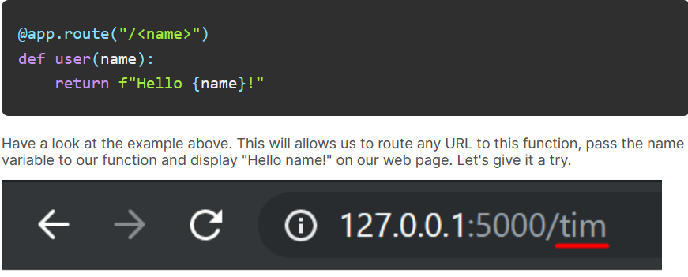Now let's move to our next web page! This time however we are going to access it using something called a dynamic url/path

## Redirects

* 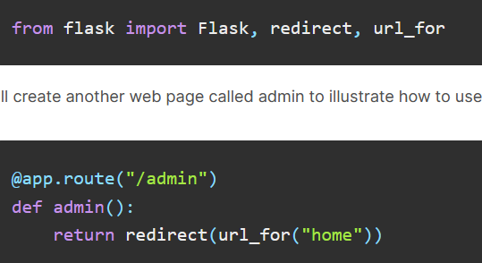The last thing to mention is how to redirect users to other pages from within our python code. To do this we will start by importing some more functions from Flask

## Rendering HTML

1. Import the render_template function from flask
2. Create a new folder called templates inside the SAME directory as our python script.
3. Create an html file, I've named mine index.html. Make sure to **put it in the templates folder!**
4. Render the template from a function in python
5. The render_template function will look in the "templates" folder for a file called "index.html" and render it to the screen. Now try running the script and visiting "/". You should see that html rendered.
   1. To note that this will override the home page path
   2. There might be a need to comment out the initial home page section
6. 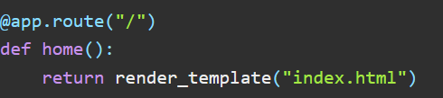\

## Dynamic HTML

* Flask uses a templating engine called jinja. This allows you to write python code inside your html files. It also allows you to pass information from your back-end (the python script) to your HTML files.
* In your HTML file you can use the following syntax to evaluate python statements. **{{Variable/Statement}}** Placing a variable or statement inside of {{}} will tell flask to evaluate the statement inside the brackets and render the text equivalent to it.

